You are Invited…
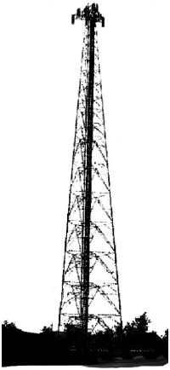

Date:___________________
Time:___________________
Place:___________________

For more information: [email@gmail.com]
Presented by your concerned
friends and neighbours

CELLULAR ANTENNAS IN YOUR NEIGHBOURHOOD:
ARE THEY SAFE?
VIDEO PRESENTATION
Discussion
Questions & Answers
Guest Speaker:_____________

Radiation Hurts Children
Proposed cell tower antenna installation at ___________________________would be close to ___schools, ___ daycares and numerous home daycare centres. We would like cell towers to be installed at a safer distance from areas of dense population, especially areas where children play and learn.

Cell Tower Radiation
Microwave radiation from cell towers harms us at the DNA level. When exposed to microwave radiation our blood cells mimic the cells of cancer patients. Some people living near cell towers or in environments where microwave radiation is present 24/7 have developed electromagnetic hypersensitivity and report these symptoms: Headaches (pins and needles, sharp pains, pressure), attention deficit (difficulty concentrating, memory lapses), disorientation (dizziness, vertigo, problems with balance), insomnia (sleep disturbances, excessive fatigue), adrenal fatigue, tinnitus (ringing in the ears), heart problems (tachycardia/racing heart, pressure in the chest), skin rashes, thyroid problems, and immune abnormalities. International studies also suggest a link between microwave radiation and the following biological effects: dementia, infertility, tumours, and neurological diseases such as MS.
Safety Code 6 is old and only sets limits regarding skin and tissue heat effects from technology emissions. It does not protect us from radiation at the DNA level. Both acute and cumulative exposures to this radiation are dangerous to our health, and especially to the health of children and elderly. It will take YEARS before these negative health effects are better documented, and by then it will be too late for those who have developed radiation-related illnesses. This is your opportunity to make a positive difference in your community. Every voice counts! Express your concerns and questions to Council along with other parents and neighbours to protect children and your community.
Please watch these videos: HYPERLINK "http://youtu.be/X8IDM8bUXsM"http://youtu.be/X8IDM8bUXsM & HYPERLINK "http://www.mybronte.ca/wp/cell-tower-health-effects"www.mybronte.ca/wp/cell-tower-health-effects
then go to HYPERLINK "http://www.mybronte.ca"www.mybronte.ca to see what happened at the Bronte fire station in Oakville.

Town Council Meeting:
Date:____________________
Time:____________________
Place:____________________
We need everyone concerned to attend this meeting to show Council that the health and wellness of our community is top priority.

Cell Tower Information Night: Date:__________________
Time:_______________
Place:_______________
Video presentation featuring
Dr. Magda Havas. Become informed about the latest research.

Petitions will be available to sign at the meeting.
For more information: [email@gmail.com]

www.C4ST.org
www.magdahavas.com
http://safeschool.ca

www.weepinitiative.org
www.wiredchild.org

