Hi everyone:

Now that the school year is drawing to a close, a Good News Update is in order !!

Please see "Dear School Council Letter" above first as precursor to what follows below :-)

At the end of the above letter are the details of my recommendation to School Council and The Peel Board of Education; Wireless Technology: A Safe Use Initiative based on Manufacturer Health and Safety warnings. Thank you Denise (School Council Co- Chairperson) for sending this off to the Peel Board of Education. I am also actively following up with Peel Public Health and the Board of Trustees, etc. on this.

In addition, noticed that this has just recently been posted by ETFO, Elementary Teachers Federation of Ontario representing 76,000 teachers. Here is Resolution # 74.

The fact that Peel teachers have taken this into consideration shows that Peel teachers want a safer use program as they too want direction of how to care for your children. To the best of my knowledge no direction has been provided to the teachers as to how to use these devices safely. I noticed that in February the Peel teachers voted to send this Resolution # 74 to the annual general meeting in August to present it to the rest of Ontario teachers. Have to wait until then to see if it becomes official of course.

74. Peel Teacher Local
That ETFO lobby Public Health Ontario, the Ministry
of Health, and the Ministry of Education to develop
and deploy an ongoing, province-wide wireless
technology safer use initiative on the safer use of
laptops, mobile phones, tablets, and all wirelessly
communicating equipment and accessories.

Rationale:
District schools boards are encouraging students to
bring your own devices without safer use policies.
The manufacturers’ health and safety warnings
include use guidelines that explain non-adherence
to those guidelines may cause personal harm or
injury. It is part of the Education Act that schools act
in the role of a prudent parent with children under
their care. Schools have a duty to understand the
manufacturers’ safer use guidelines when using
these devices.

The Peel Board seems to be the most aggressive Board with their Wi-Fi and B.Y.O.D installation. Teachers, not just here, but across Canada, are expressing concern (Canadian Teachers Federation). With what seems to be this lack of direction, teachers seem unprepared, yet they are the custodians of our children. The School Board is the "Prudent Parent" in our place under the Education Act during the school day so this is unacceptable.

If teachers want direction on how to properly implement a safer Bring Your Own Device (B.Y.O.D.) program, we, as parents, should, therefore, support them.

By all means, please let me know if you do not wish to receive further emails.

:-)

Paulette Rende
School Council Parent Rep.
Westacres Public School

ps. Supporting Information on the subject is below if you have a few moments.

Cellphone radiation absorption differences by age.

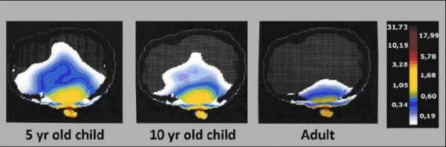
The Federal Safety Code, Safety Code 6, which the Peel School Board is using, makes no reference to children and has no safety benchmarks for children. It is based on an adult male only. Children are more vulnerable due to thinner skulls etc. so this is a concern.

Safety Code 6 also does not address "near" or "cumulative" radio frequency radiation exposures. "Near" exposure radiation levels are those at point of contact with the body by Ipad or cellphone. Blackberry, warns that radiation levels could exceed safety standards if device is kept on the body. If it might exceed safety standard when that standard is based on a Adult Male, imagine how harmful it potentially might be for a child. A precautionary approach like the WIRELESS TECHNOLOGY; A SAFE USE INITIATIVE is needed.

Health Canada, I also note, does "encourage parents to reduce their children's RF exposure from cell phones since children are typically more sensitive to a variety of environmental agents". This warning runs counter to The Peel Board of Education's B.Y.O.D . program which has no Safe Use Guidelines attached. If this warning is addressed to parents, why does this warning not apply to schools where children spend 1/3 to almost 1/2 of the day if you include before and after school programming???? Should not the word "parents" in the Health Canada warning also apply to all school boards who, are by law, under the Education Act, the "prudent parents" of our children while they are at school ???

Manufacturer warnings need to be abided by and supervised for in our schools. Parents would do so at home.

Blackberry, for it's cellphone product, Z10 Smartphone, states very clearly that:

"When you wear the Blackberry smartphone close to your body, use a RIM approved holster with an integrated clip, or maintain a distance of .59 in. (15 mm) between your Blackberry Smartphone and your body while the Blackberry Smartphone is transmitting. Use of body-worn accessories, other than RIM approved holsters with integrated clip, might cause your Blackberry smartphone to exceed radiofrequency exposure standards if the accessories are worn on your body while the Blackberry smartphone is transmitting. The long term effects of exceeding radio frequency standards might present a risk of serious harm".

Manufacturer and Health Canada warnings are being ignored by the federal Safety Code 6, Peel Public Health and school boards, as are The World Health Organization's health warnings. The World Health Organization's health warning does include Wi-Fi. It applies to all radio frequency radiation regardless of source: Wi-Fi router or cellphone or Ipad.
The belief that this World Health Organization warning applies only to cell phones and not Wi-Fi is false and inaccurate. Statements of it applying only to cellphones are misleading. Parents need to be informed.
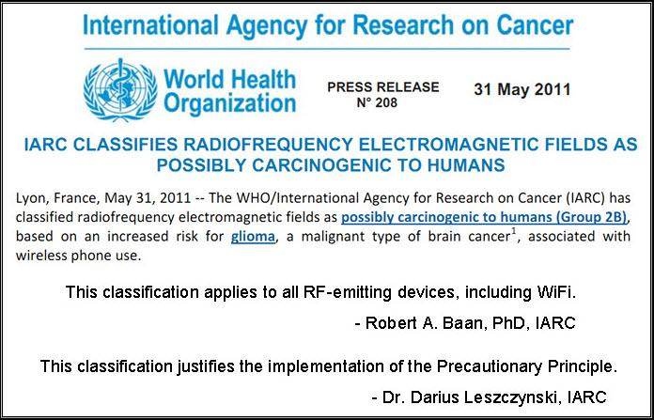
In October 2013, The Canadian Teacher's Federation; acting in the best interests of all children and teachers, recommended to the Royal Society of Canada (which was reviewing SC6) that:
1) Safety Code 6 include a recommendation for prudent use of Wi-Fi whenever possible including the recommendation to limit consistent exposure in schools by turning off wireless access points when not in use.
2) Safety Code 6 exposure thresholds be based on both thermal and biological effects (not just thermal) of exposure to Wi-Fi.
3) An education program regarding the relative safety of Wi-Fi exposure be implemented and that appropriate resources be developed to educate the public regarding ways to avoid potential exposure risks of Wi-Fi access points and devices.
The full CTF document is at http://www.ctf-fce.ca/Research-Library/BrieftoExpertpanel.pdf

The recently released Peel Board of Education Electromagnetic Radiation Report : A study of 25 schools

http://www.peelschools.org/aboutus/21stCentury/byod/parentresources/Documents/Full%20Wi-Fi%20testing%20report%20-%20for%20website%20-%20May%202014.pdf

states that average RF radiation levels are below Safety Code 6. Canada's Safety Code 6 however, is one of the least protective safety codes in the world, even Russia and China have safer standards. It does not have safety benchmarks for children or pregnant women, nor, as mentioned earlier, does it address "near" and "cumulative" exposures.

Voluminous research links wireless radiation exposure at levels much lower than Safety Code 6 (10.0 W/m2) to serious biological health effects such as cancer, DNA damage and reproductive disorders.

For this reason and as a point of comparison, Toronto Public Health adopted and maintained a Prudent Avoidance Policy that is 100 times safer ( .1 W/m2) than that of Safety Code 6 (10.0 W/m2) . The Toronto Public Health guideline was geared to provide better protection of the general population in the vicinity of ie. cell towers. In comparison, the Peel Board School Electromagnetic Radiation Report shows consistent peak radiation levels in our children's classrooms that surpass Toronto Public Health 's Prudent Avoidance guideline. A worrisome point as children are more vulnerable.

The general population near cell towers in Toronto seem to be more protected from RF/microwave radiation than are the more vulnerable children in classrooms. This shows how the federal safety code is in dire need of revision and update.

Short videos:

http://www.youtube.com/watch?v=Xtd-y2C9lH4 ---CBC and Dr. Devra Davis, former White House Advisor. Dated but good.
http://www.youtube.com/watch?v=XIPtEYlOupE --Teens and Cellphone Safety. Teachers, an idea for your students.

http://rt.com/shows/the-truthseeker/manifacturers-cell-phone-warning-447/ - Good overview, January 2014

http://www.youtube.com/watch?v=I5udG8OCZWY Dr. Olle Johansson, Neuroscientist, 2014

http://www.preventcancernow.ca/what-are-the-full-economic-health-and-security-costs-and-benefits-of-wired-versus-wireless-technology - Dr. Devra Davis, Former White House Advisor, 2014

www.C4ST.org Canadians for Safe Technology website.

Hopefully I have showed that a precautionary approach for our schoolchildren, such as the Wireless Technology: A Safe Use Initiative Based on Manufacturer Health and Safety Warnings, is warranted until RadioFrequency Radiation/ Microwave Radiation is proven harmless.

Thank you!

